**Advocacy**

**Narrowing Opportunity Gaps**

(Black text is the template, blue text is for your reference only)

**Title:** Narrowing Opportunity Gaps

## Description:

In this module, you will practice identifying inequities that often prevent students from reaching their full potential, known as *opportunity gaps*. By applying strategies to assist with narrowing *opportunity gaps*, you are playing a direct role in advocating for your students!

## Learning Objectives:

Upon completion of this module, you will be able to:

* Define the term *opportunity gap*
* Identify examples of *opportunity gaps* in tutoring settings
* Explain strategies to narrow *opportunity gaps* in tutoring settings

## Tutor’s Experience Level:

How would you describe your tutoring experience and skills?

Beginner tutor- 1 (no experience)

Expert tutor- 5

## Scenario 1:

Before we get started, please answer the following questions to help assess your existing knowledge. 

You are a math tutor working with a small group of students from various schools within the city to help them prepare for college entrance exams. You instructed all of the students in the group to bring a graphing calculator to each session. One of the students in the group, Tyrone, continues to forget his graphing calculator at school every session. This is beginning to impact your lessons, which involves showing students how to input problems into the calculator to solve them faster as a strategy to score higher on the upcoming college entrance exam. You begin to wonder why Tyrone keeps forgetting his calculator, so you ask him to stay for a few minutes after the tutoring session ends to speak with him.

[[image link](https://www.pexels.com/photo/serious-black-student-solving-math-equation-on-blackboard-6238048/)]

[Predict/Decide- Open Response, asking them to predict or decide what is the recommended tutor response in this situation]

1. What exactly would you say OR how exactly would you respond in order to narrow *opportunity gaps* that may be causing the Tyrone to show up to the session without a graphing calculator?

[Predict/Decide - MCQ]

2. Which of the following strategies below do you think would best support identifying *opportunities gaps* influencing Tyrone’s situation?

I would say to the student:

[Insert believable and relevant tutor responses here with one correct (or most desired) and three incorrect (or less desired. You can have three options as well.]

1. “Tyrone, I really want to see you do well on your upcoming exam, however, you need to remember to bring your graphing calculator next session.”
2. “ Tyrone, I know you are not forgetting your graphing calculator, tell me what is really going on? I am here to help you.”
3. “Tyrone, would it be helpful for you to use this extra graphing calculator that I have for upcoming sessions?”
4. “Tyrone, how can I help you remember to bring your graphing calculator next session?”

[Explain- Open]

3. Why do you think the approach you selected in the previous question will narrow opportunity gaps that may be causing the student to show up to the session without a graphing calculator?

[Explain- MCQ)

4. Which of the following statements aligns with the rationale you chose and explained in the previous two questions.

[Explain one correct (or most desired) option rationale and three incorrect (or less desired) responses being sure to capture common errors and misconceptions among tutors.]

1. Showing the student you care will help him remember his supplies for future tutoring sessions and bridge the *opportunity gap*.
2. Asking the student to share more about his situation will create an opportunity to build trust and foster relationship building.
3. Presenting a solution to the situation will narrow the *opportunity gap* without embarrassing the student.
4. Helping the student find solutions to their problem will develop self-advocacy skills.

[Observe] - (Give desired, recommended response, according to research with explanation)

## Research Recommendation(s), Research says…

An *opportunity gap* in education is defined by Milner (2019) as, “inequities in systems, structures and practices, among other factors, that can prevent children from reaching their potential.” One example of this can be seen by the unequal distribution of resources in high-poverty schools compared to low-poverty schools. According to the Economic Policy Institute, “education funding generally is inadequate and inequitable… (Allegretto, et.al, 2022).” *Opportunity gaps* related to resource distribution may show up in tutoring sessions as students not having the materials necessary, such as a graphing calculator, to engage in the tutoring session.

For this reason on [Question number 2], the option listed below is the most desired response or correct answer:

C. “Tyrone, would it be helpful for you to use this extra graphing calculator that I have for upcoming sessions?

The above strategy seeks to address the differences in access or *opportunity gap* by providing the student with a solution to bridge the gap in the short term. It is important to note, sometimes there will be *opportunity gaps* that are beyond what the tutor is able to resolve and will require a larger intervention at which point the tutor should seek support from the student’s caregiver, school or other appropriate entity.

[Explain- Open]

5. In your own words, please explain why it is important to identify *opportunity gaps* the students you work with may experience ?

The info graphic below shows examples of Opportunity Gaps and how they impact students with varying socioeconomic resources. (Can we obtain permission to use or recreate something similar?)

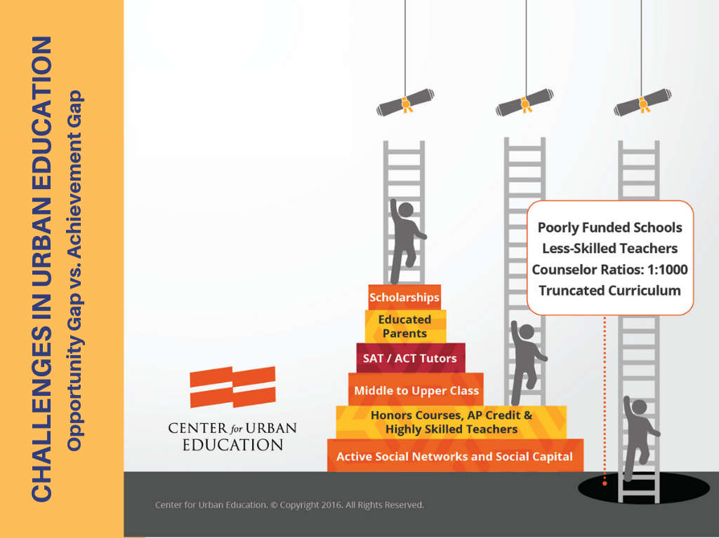

([Link to image](https://cue.usc.edu/equity/))

6. How much do you agree or disagree with the expert belief of *opportunity gaps* creating barriers to student learning?

Strongly disagree-1

Somewhat disagree-2

No opinion-3

Somewhat agree-4

Strongly agree-5

7. Explain why you agree or disagree.

[Explain- Multiple Choice]

8. What is an example of an *opportunity gap* a student you tutor may experience?

A. A student not completing an online homework assignment because they do not have access to the internet at home.

B. A student arrives late to tutoring sessions because they take public transportation which is often off schedule.

C. A student is unable to complete an online assessment during the allotted time of the tutoring session because they are unfamiliar with using a laptop computer.

D. All of the above

## Research Recommendation

*Opportunity gaps* are deeply rooted in systemic inequity. Milner suggests, “*opportunity gaps*, especially those related to diversity, exist at all levels in education and are present in the lives of both educators and students.” Students may not have access to the resources they need to reach their full potential, such as, reliable internet at home, transportation, or the necessary technology. Therefore, Option D: All of the above, is the most desired response or correct answer.

## Scenario 2: [Same a pre-instruction]



[[image link]](https://www.pexels.com/photo/children-in-school-uniforms-watching-movie-in-classroom-10646408/)

You are tutoring a student and ask them about what they are learning in their math class in school. The student, Angelina, shares that she does not have a consistent math teacher. She states she currently has various substitute teachers as the school is looking for a permanent teacher. Angelina says her substitute teachers often show movies during her math class. Angelina goes on to share that sometimes the substitute teachers give the class worksheets to complete.

[Predict/Decide- Open Response, asking them to predict or decide what is the recommended tutor response in this situation]

9. What exactly would you say OR how exactly would you respond in order to narrow *opportunities gaps* the student may be experiencing due to not having a consistent math teacher?

[Predict/Decide - MCQ]

10. Which of the following strategies below do you think would best support *opportunities gaps* the student may be experiencing?

I would say to the student:

1. “Angelina, I am sorry to hear that you don’t have a permanent math teacher. That must be very hard for you. Let’s get started today with practicing some review problems.”
2. “Angelina, I am going to contact and follow up with your mom to see if there is a way that we might address what is happening in your math class.”
3. “Angelina, that sounds like fun, what kind of movies do you watch in math class?”
4. “Angelina, that is terrible, your school is really failing you by not providing you with consistent, quality math instruction.”

[Explain- Open]

11. Why do you think the approach you selected in the previous question will address the *opportunity gap* the student is experiencing?

[Explain- MCQ)

12. Which of the following statements aligns with the rationale you chose and explained in the previous two questions.

1. Acknowledging what the student shared is important and letting the student know that you feel for them shows empathy. Showing empathy and focusing on what is in your control is the best path forward.
2. Understanding when an *opportunity gap* is beyond what is in our control and making others aware of the issue who are better positioned to resolve the problem is what is reasonable for a tutor in this situation.
3. Asking the student more questions about her math experience will support authentic relationship building, which is a key component of a tutor/student relationship.
4. Empathizing with the student by expressing frustration will help the student develop self efficacy and let the student know you care.

## Conclusion

*Opportunity gaps* in education impact students and educators in a myriad of ways. It is important to be able to identify *opportunity gaps*, and as a tutor, recognize ways to help narrow those gaps. In addition, it is sometimes necessary to make others aware of inequities that need to be addressed. Again, there will be *opportunity gaps* that are beyond what the tutor is able to resolve and will require a larger intervention at which point the tutor should seek support from the student’s caregiver, school, or other appropriate person. For this reason, for Question 10, the option listed below is the most desired response for responding to Angelina:

B. “Angelina, I am going to contact and follow up with your mom to see if there is a way that we might address what is happening in your math class.”

This approach recognizes the *opportunity gap* that needs to be addressed is beyond what the tutor is able to support.

In summary, this lesson explored the definition of *opportunity gap*, ways that *opportunity gaps* show up in tutoring settings, and strategies to narrow or address *opportunity gaps* when they arise.

**Further Reading:**

For more information regarding how to identify and narrow *opportunity gaps* in your tutoring, check out the resources below:

Video: [How America's public schools keep kids in poverty](https://www.youtube.com/watch?v=7O7BMa9XGXE) | Kandice Sumner

TedTalk

Deeper Dive: [Project READY: Reimagining Equity & Access for Diverse Youth](https://ready.web.unc.edu/section-2-transforming-practice/module-14-inequity-in-the-educational-system/)

**References:**

Milner, R. (2019, February 19). *Opportunity gap: To create a more just and Equitable Society, black students need a true education, not just more 'schooling'*. Vanderbilt University. Retrieved November 12, 2022, from <https://news.vanderbilt.edu/2019/02/19/opportunity-gap-to-create-a-more-just-and-equitable-society-black-students-need-a-true-education-not-just-more-schooling/>

Allegretto, S., Garcia, E., & Weiss, E. (2022, July 12). *Public education funding in the U.S. needs an overhaul: How a larger federal role would boost equity and shield children from disinvestment during downturns*. Economic Policy Institute. Retrieved November 12, 2022, from <https://www.epi.org/publication/public-education-funding-in-the-us-needs-an-overhaul/>

## Feedback

Indicate how much you agree or disagree with the following statements:

The lesson was easy to understand.

Strongly disagree-1

Somewhat disagree-2

No opinion-3

Somewhat agree-4

Strongly agree-5

I’m confident I can apply what I learned to my tutoring.

Strongly disagree-1

Somewhat disagree-2

No opinion-3

Somewhat agree-4

Strongly agree-5

Please provide any feedback or comments related to this training module.